DAY 81 SOLUTION

Q1. Problem Statement: Data Connections and Charts

Step - 1: Load the given dataset into a tableau workbook

Step - 2: Change the “quarter-end date” column’s the data type to date

Step - 3 : Plot line graph for given an entire timeline for “Total Gross Value Added”.

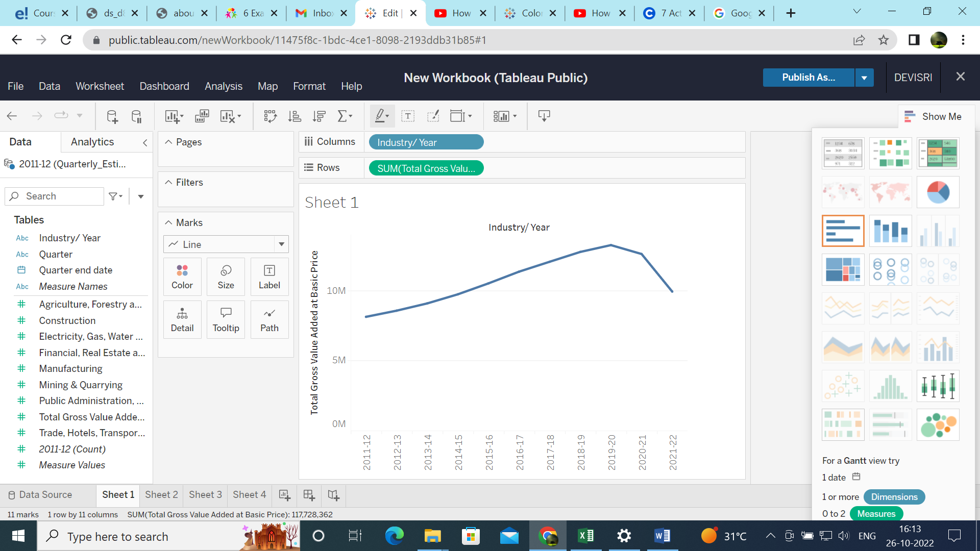

Step - 4 : Open a new worksheet and find out the total contribution of Agriculture, Forestry, and Fishing fields to GDP for each year and each quarter with the help of a bar chart (use different color pellets to represent each quarter.

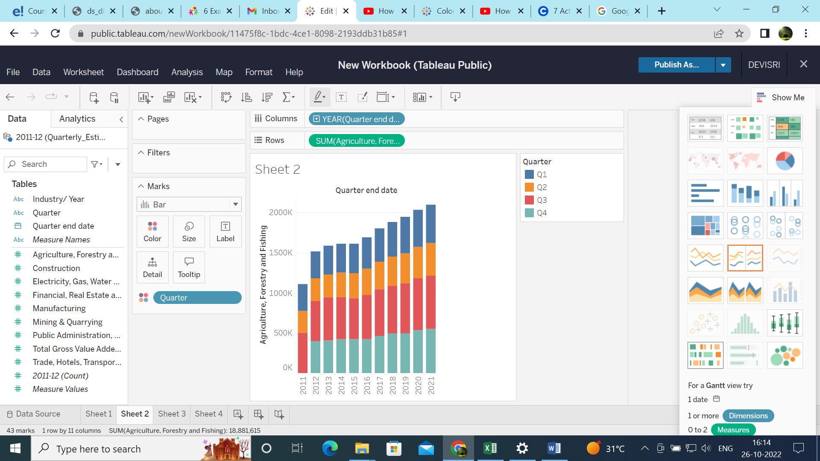

Step - 5 : Compare the contribution of manufacturing, mining, quarrying, and financial and real estate sectors and their contribution to GDP each year quarter-wise with the help of a bar chart

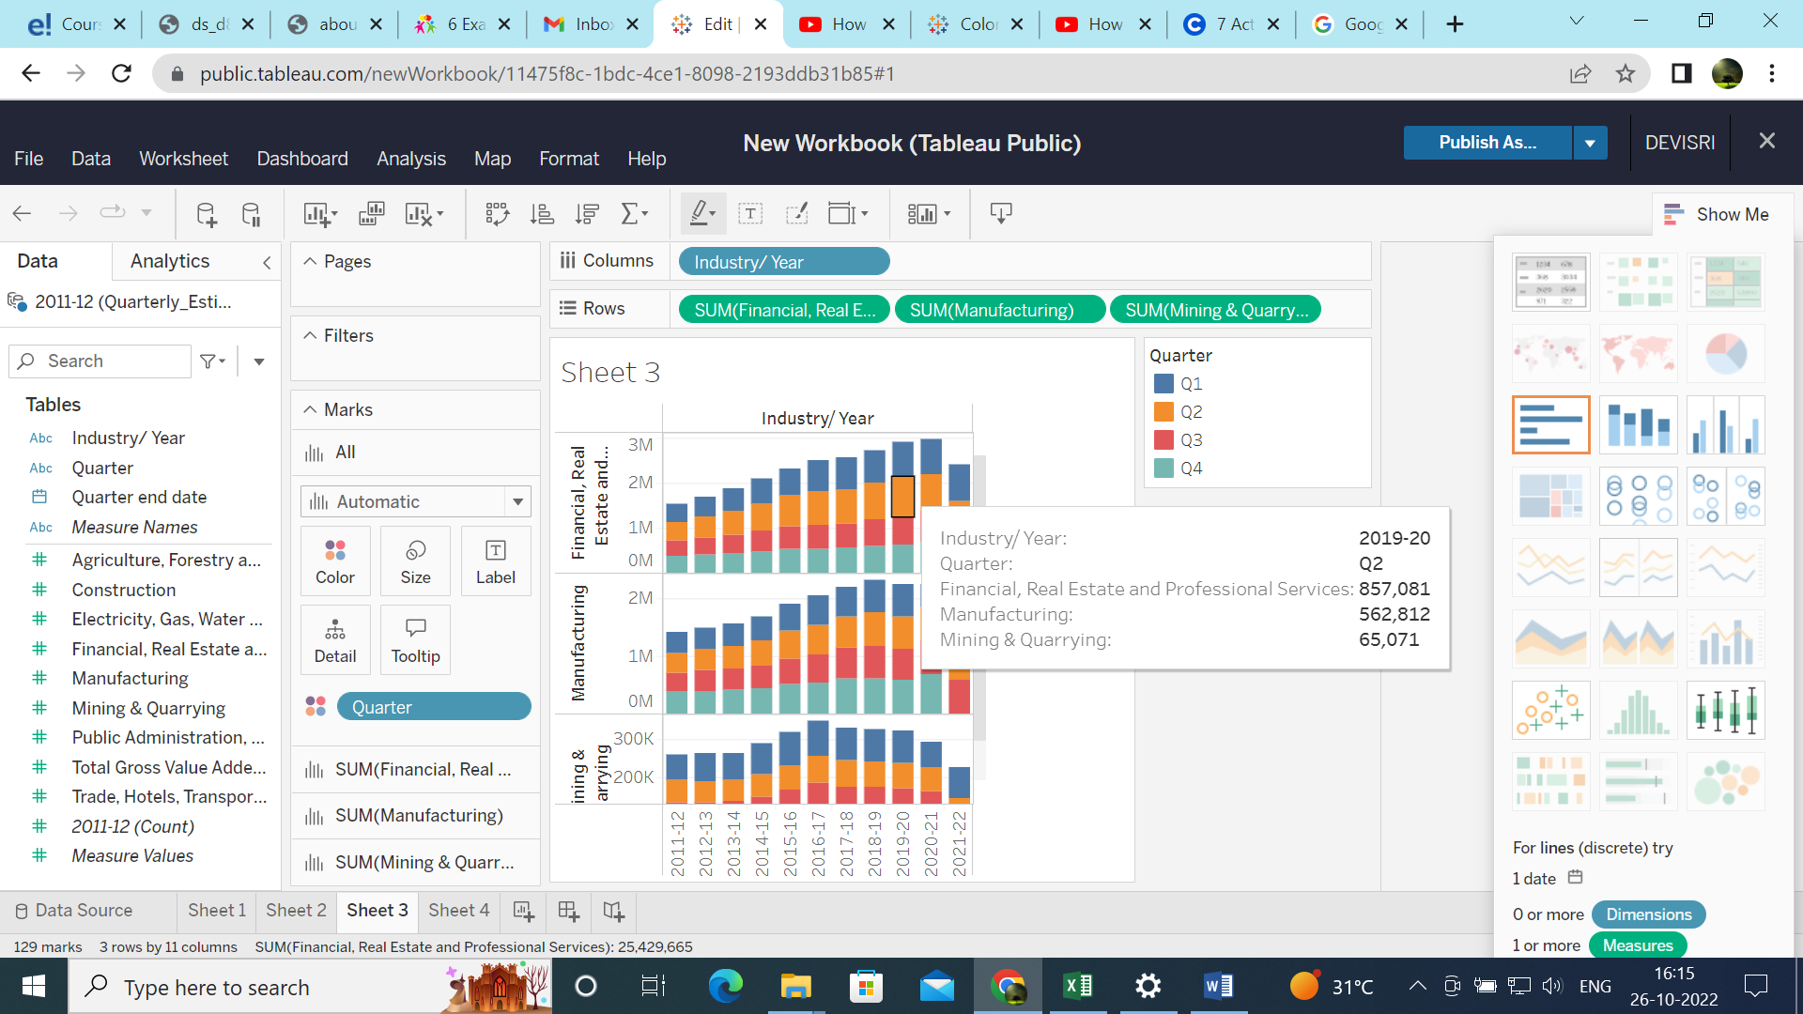

Step - 6 : Find out in which quarter the agriculture and fishing sector contributed more to GDP in all years with the help of a pie chart and try to conclude why

